* **MATRICES SUBSTRACTION**
  + To subtract two matrices: subtract the numbers in the matching positions:

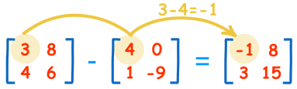

These are the calculations:

|  |  |
| --- | --- |
| 3−4=−1 | 8−0=8 |
| 4−1=3 | 6−(−9)=15 |
|  |  |

* **NEGATIVE**
  + The negative of a matrix is also simple:

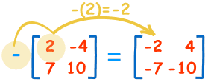

These are the calculations:

|  |  |
| --- | --- |
| −(2) = −2 | −(−4) = +4 |
| −(7) = −7 | −(10) = −10 |

**Note:**

* Subtracting is actually defined as the Addition of a negative matrix: A + (−B)